Removing Duplicates

Definition
# Source: AI Source: Provided by: [Data Path: Persons Table -> ID Column: 1, Name_En Column: Motasem Essam] -> From: [Chatgpt (GPT‑5 Mini)] on [12/10/2025]
Removing Duplicates is the process of identifying and eliminating repeated records in a dataset so that each data entry appears only once.
- Duplicate data can occur due to multiple entries, system errors, or data merging from different sources.
- Removing duplicates helps ensure accurate analysis and reliable results.
Key idea:
It is like removing repeated files from a folder so that only one correct version remains.

Characteristics of Removing Duplicates
# Source: AI Source: Provided by: [Data Path: Persons Table -> ID Column: 1, Name_En Column: Motasem Essam] -> From: [Chatgpt (GPT‑5 Mini)] on [12/10/2025]
- Detects identical or nearly identical records in a dataset
- Ensures that each record appears only once
- Often performed during data cleaning or preprocessing
- Can be done using software tools, database queries, or spreadsheet functions
- Helps prevent double counting or incorrect analysis

Example
# Source: AI Source: Provided by: [Data Path: Persons Table -> ID Column: 1, Name_En Column: Motasem Essam] -> From: [Chatgpt (GPT‑5 Mini)] on [12/10/2025]
Original dataset with duplicates:
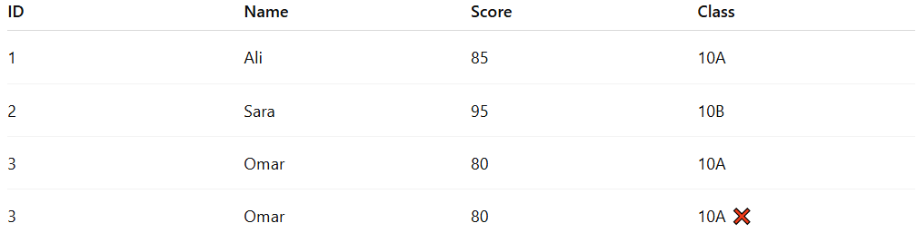
ID | Name | Score | Class
1 | Ali | 85 | 10A
2 | Sara | 95 | 10B
3 | Omar | 80 | 10A
3 | Omar | 80 | 10A ❌
The last row is a duplicate record.
After removing duplicates:
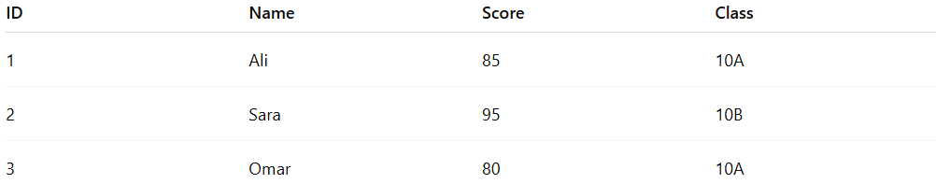
ID | Name | Score | Class
1 | Ali | 85 | 10A
2 | Sara | 95 | 10B
3 | Omar | 80 | 10A

Example Section
# Source: AI Source: Provided by: [Data Path: Persons Table -> ID Column: 1, Name_En Column: Motasem Essam] -> From: [Chatgpt (GPT‑5 Mini)] on [12/10/2025]
A school database accidentally stores the same student record twice.
Before cleaning:
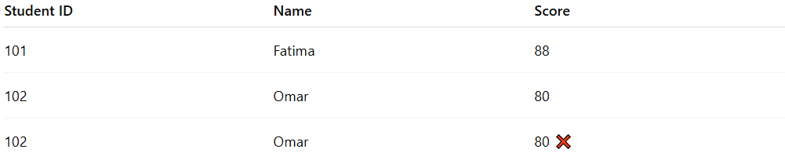
Student ID | Name | Score
101 | Fatima | 88
102 | Omar | 80
102 | Omar | 80 ❌
Cleaning process:
- The system detects that Student ID 102 appears twice.
- The duplicate record is removed.
After cleaning:
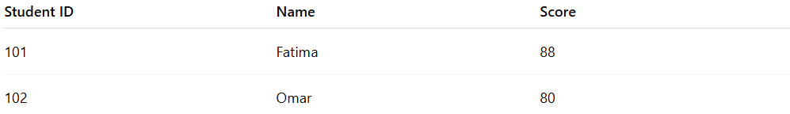
Student ID | Name | Score
101 | Fatima | 88
102 | Omar | 80
This ensures accurate student records and correct analysis.

Advantages
# Source: AI Source: Provided by: [Data Path: Persons Table -> ID Column: 1, Name_En Column: Motasem Essam] -> From: [Chatgpt (GPT‑5 Mini)] on [12/10/2025]
- Improves data accuracy and consistency
- Prevents double counting during analysis
- Reduces data redundancy
- Makes datasets cleaner and easier to manage

Disadvantages
# Source: AI Source: Provided by: [Data Path: Persons Table -> ID Column: 1, Name_En Column: Motasem Essam] -> From: [Chatgpt (GPT‑5 Mini)] on [12/10/2025]
- Detecting duplicates can be difficult in very large datasets
- Some duplicates may not be exactly identical, making them harder to identify
- Incorrect duplicate removal may delete valid data
- Requires careful validation before removing records

